**Microsoft Flow Templates Duplicate Identification Tool**

**Prepared for**

**Flow Project**

Version 0.1 Draft

**Prepared by**

Anil Kumar Rongala – Sonata Software

1. Table of Contents

1 Table of Contents 2

2 Tool Introduction 3

2.1 Prerequisites 4

2.2 How to Execute 4

3 Tool Navigation and Features 5

3.1 Navigation and UI 5

3.2 Feature 1: Display only Connections of all JSON Files on grid 6

3.3 Feature 2: Display only Triggers of all JSON Files on grid 6

3.4 Feature 3: Display only Triggers of all JSON Files on grid 7

3.5 Feature 4: Get Filenames of All JSON files in the folder 8

3.6 Feature 5: Find Duplicate templates 8

4 TODOs/Enhancements for Next Version 11

1. Tool Introduction

The Templates Duplicate Identification tool was developed to identify the duplicates among the template files specified in the template folder. The tool requires the path of the folder containing the templates. Once you click on Connections button it picks up all the templates in the specified folder and lists them along with the tags of Connections, Trigger connected, Trigger and Actions from the file templates.

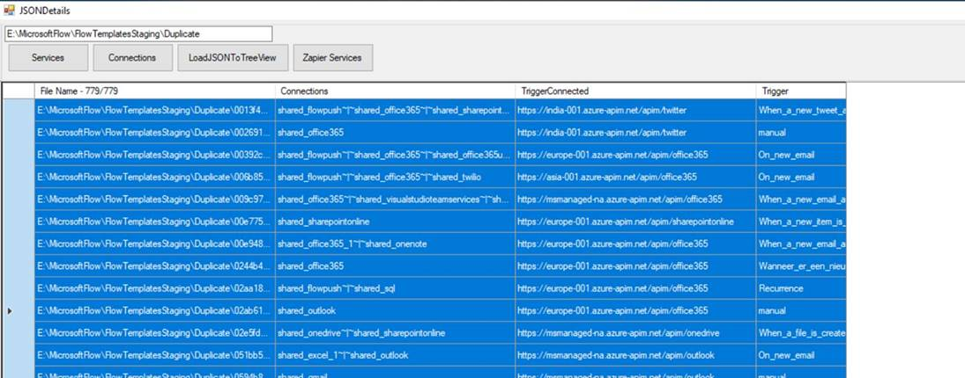

We can select from the grid and copy the details into excel worksheet or we also have a utility to export this to excel. Sort the data in Excel by Connections, Triggerconnected, Trigger and Actions in the same sequence to get the duplicates.



There is another feature built within this tool to compare file contents w.r.t how much % of content match is found. All the file contents where % of content match is more than 85% can be eliminated as duplicates

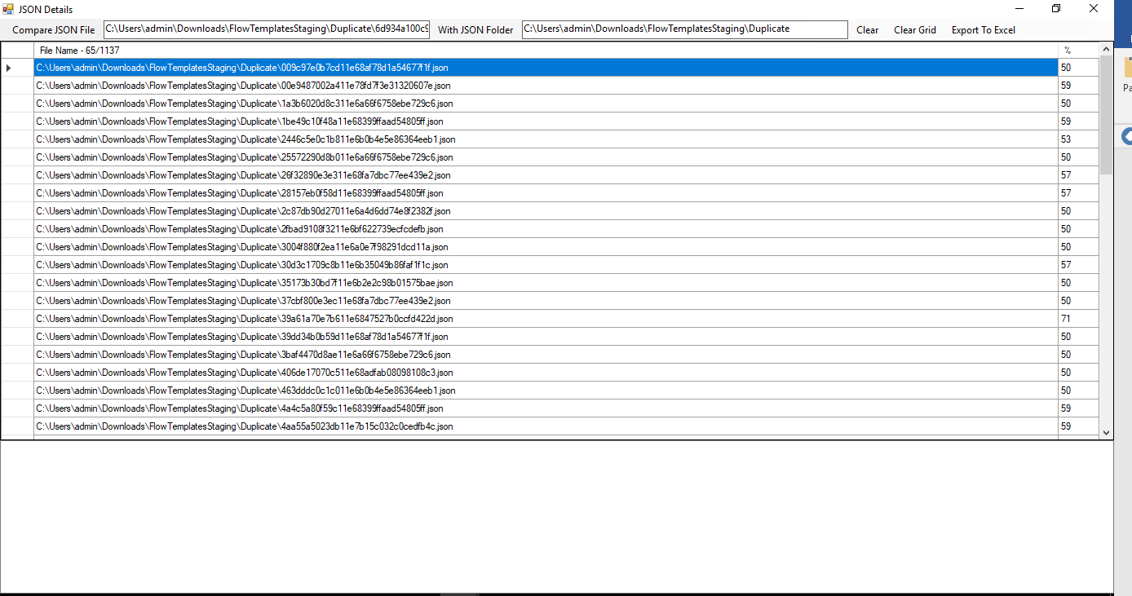

* 1. Prerequisites

Tool is developed using Visual Studio

Prerequisites: Newtonsoft.Json & Newtonsoft.Json.Linq

To install Json.NET, run the following command in the [Package Manager Console](https://docs.nuget.org/docs/start-here/using-the-package-manager-console)

**Install-Package Newtonsoft.Json**

* 1. How to Execute

Run the executable file **MSFlowDuplicateLister.EXE**

1. Tool Navigation and Features
   1. Navigation and UI

UI for the tool will be as follows:

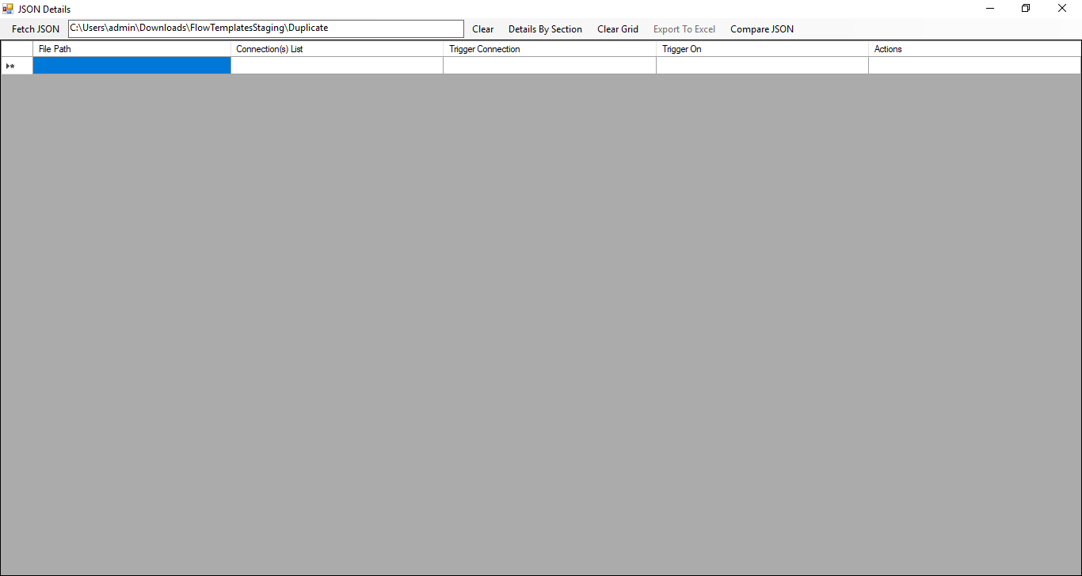

Details of each of the controls in the UI form is mentioned below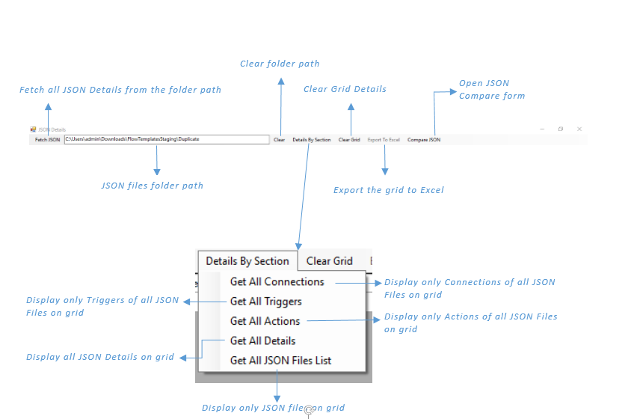

* 1. Feature 1: Display only Connections of all JSON Files on grid

When you click on Menu Item “Get All Connections” fetches only the Connections details of all JSON files from the provided folder path. If any template contains more than one connector then each connector was separated with “– “.

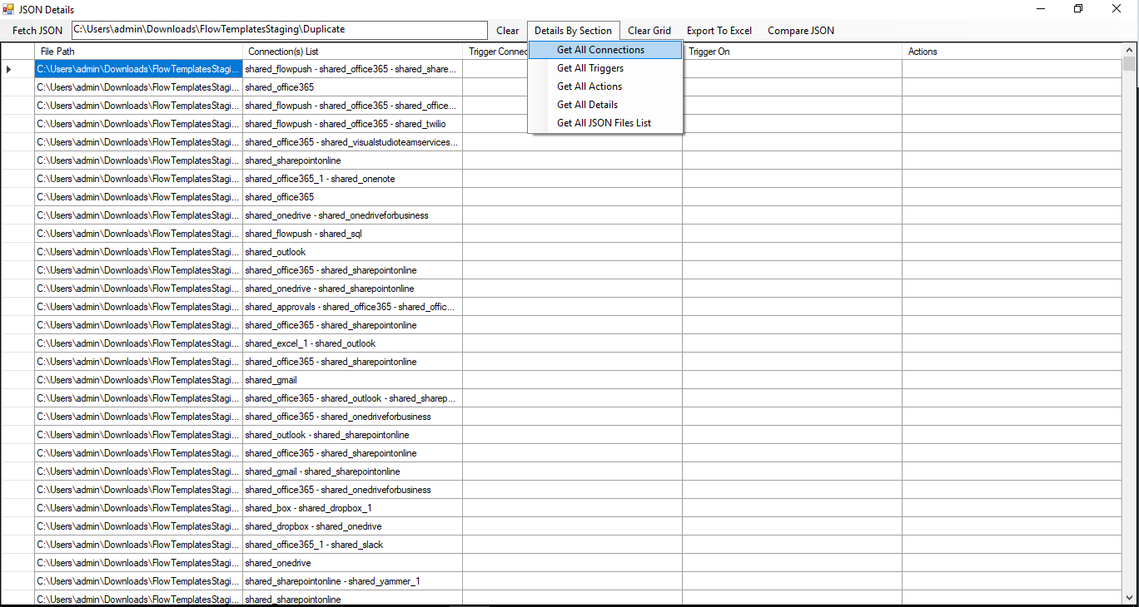

TODO: Based on the connection list, mention the appropriate connectors used in each of the template.

* 1. Feature 2: Display only Triggers of all JSON Files on grid

When you click on Menu Item “Get All Triggers” fetches only the Trigger details of all JSON files from the provided folder path.

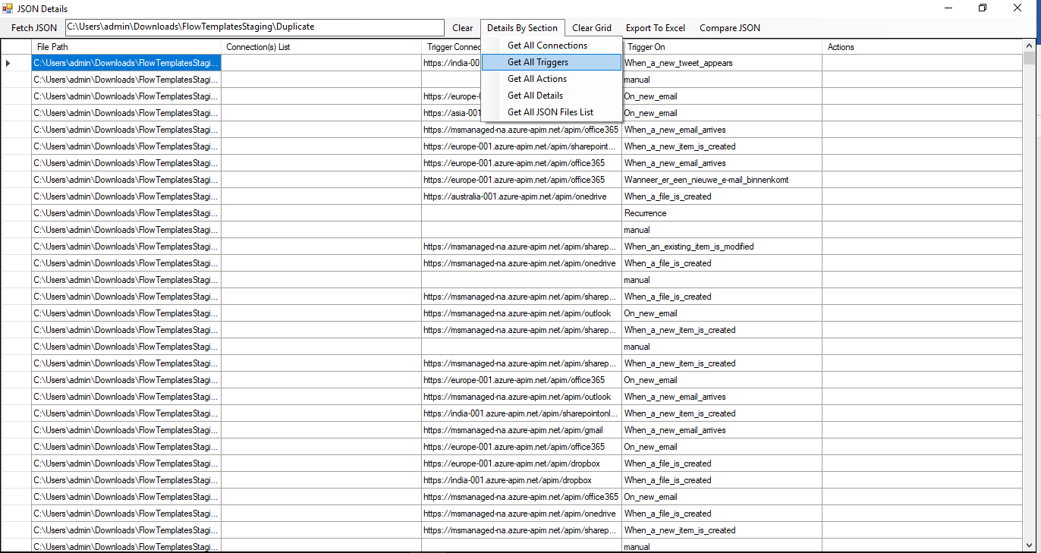

* 1. Feature 3: Display only Triggers of all JSON Files on grid

When you click on Menu Item “Get All Actions” fetches only the Actions details of all JSON files from the specified folder path. If any template contains more than one action, then each action will be separated with “, “. Exporting the file in (.CSV) format, each action will come with a separate column

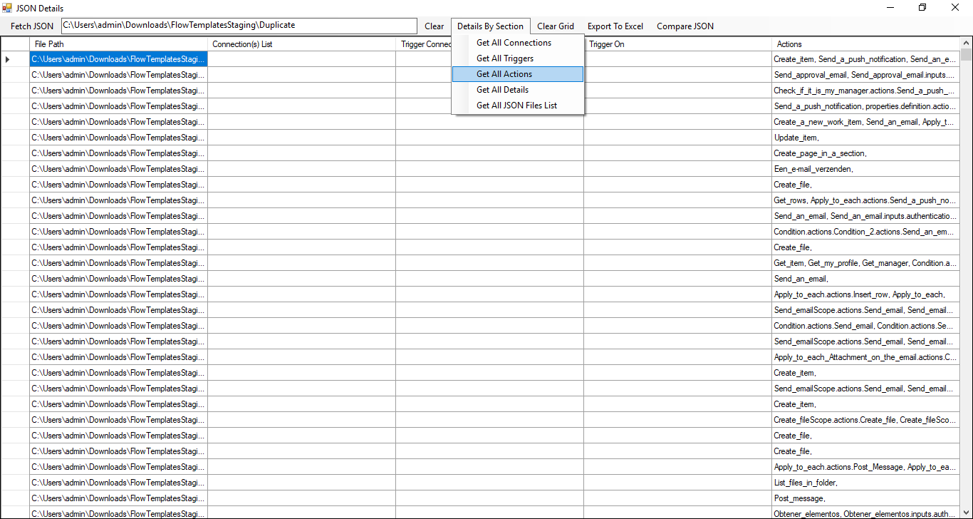

* 1. Feature 4: Get Filenames of All JSON files in the folder

When you click on Menu Item “Get All JSON Files List” fetches all the file names of all JSON files from the provided folder path.

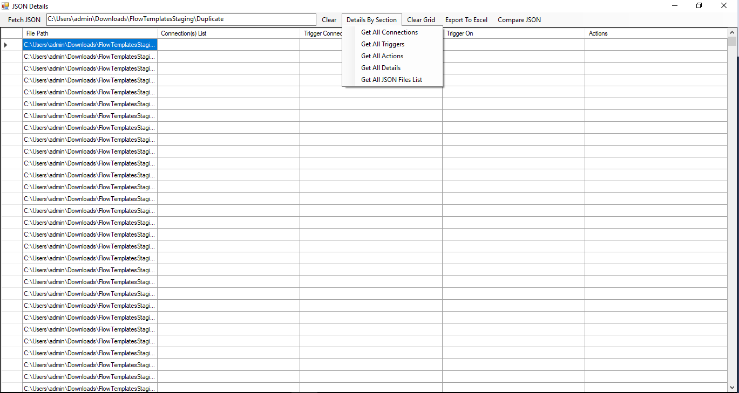

* 1. Feature 5: Find Duplicate templates

**Step 1 -** When you click on Menu Item “Fetch JSON” or “Get All JSON Files List” from Menu Item “Details By Section”, tool fetches all the details of all JSON files from the specified folder path into the grid. If any template contains more than one connector then each connector was separated with “– “. If any template contains more than one action then each action was separated with “, “and display on grid.

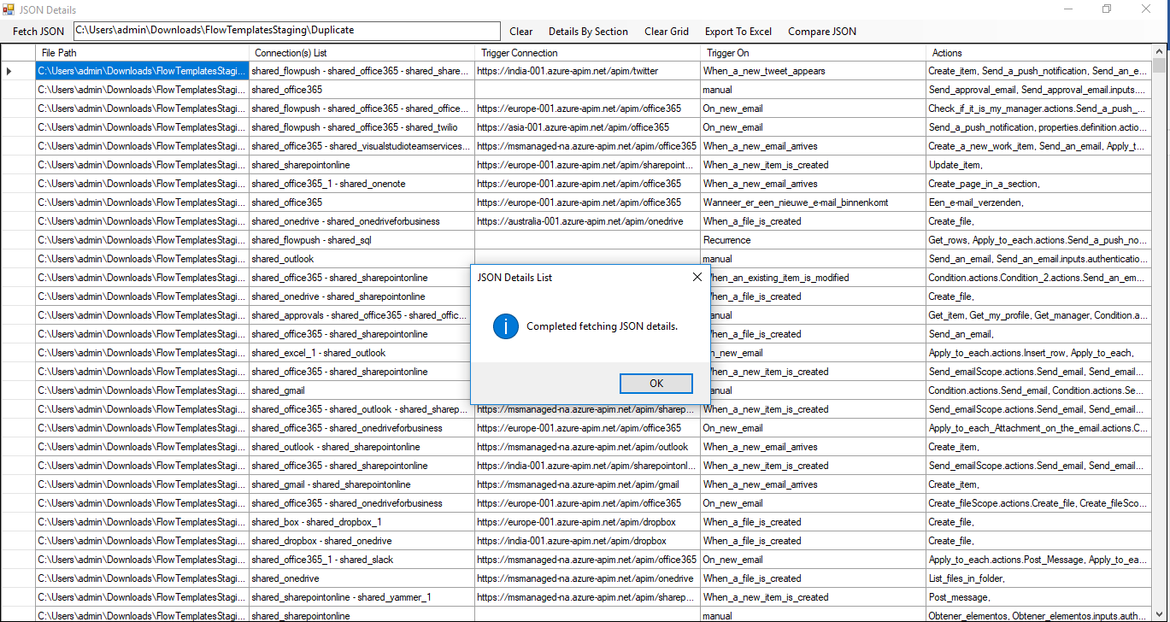

**Step 2 - Export to Excel**

Once you get the details on a grid, click on Menu Item “Export To Excel” will prompt for the location where the file need to be saved. Content of the grid will be exported to excel in CSV format.

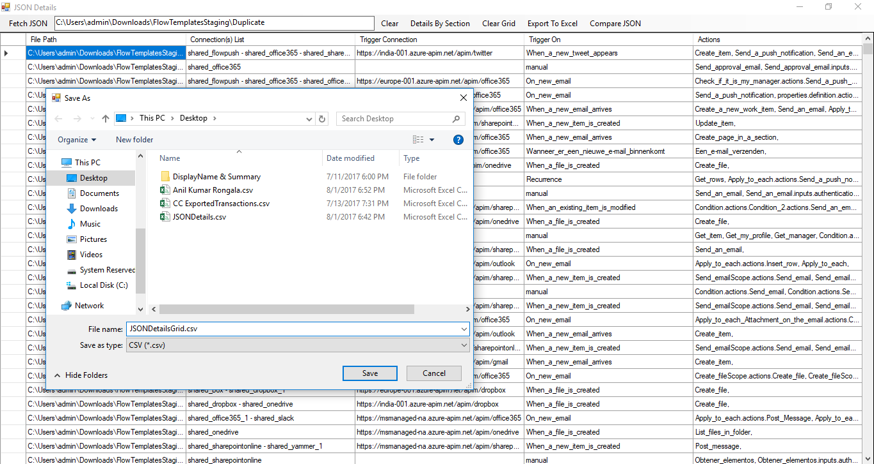

**Manual comparison in Excel**

We can sort the data in Excel by Connections, TriggerConnected, Trigger and Actions in the same sequence. As an illustration, below table is a snapshot of part of the result after we have sorted the data. In this scenario, 3rd row, 4th row and 5th row belong to same connection with same trigger and action. Hence we identified these as duplicates.



**Step 4- Compare JSON files to get the % of content match**

Click on Menu Item “Compare JSON”, opens below window.

Provide JSON file path and folder path where the files should compare with and click Menu item “Compare JSON File” which gives below results.

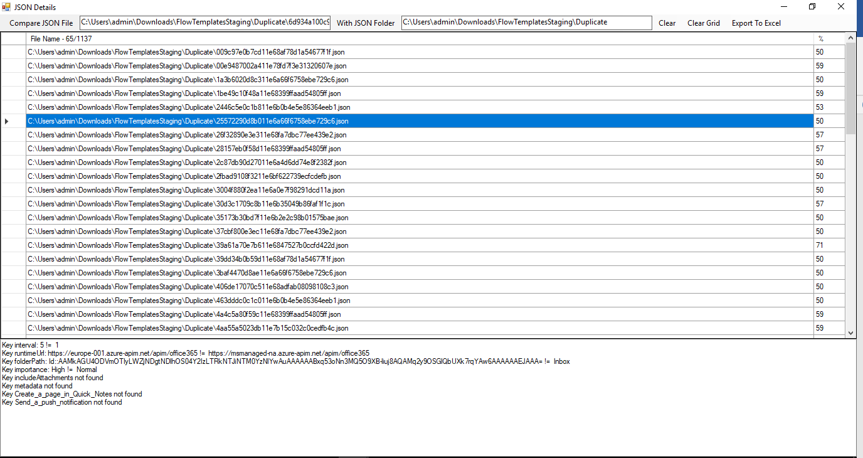

When you select a row from the results on the grid it will give the difference of the files.

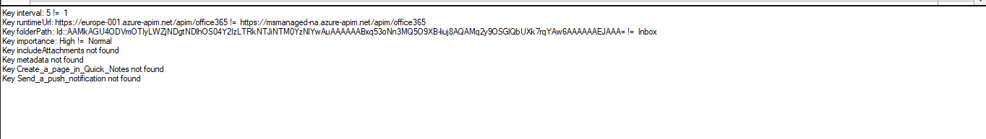

As we see the above illustration, % column provides how much % of content match is found. As a guideline we can eliminate anything that is above 85% after a quick check.

1. TODOs/Enhancements for Next Version
2. Add Criteria to filter out invalid templates
3. Mention the duplicates justification in the Remarks column in the excel sheet
4. Mention the connectors used in the template
5. Add Criteria to filter out Non English templates